AIoT Developer InnoWorks 2026 - Hosted by Phenikaa University - Initiated by Advantech
PROPOSAL FORM FOR ADVANTECH AIoT InnoWorks 2026
Theme: Edge Computing & AI-Powered WISE Solutions | Field: Energy & Environment

PART 1 - OVERALL INFORMATION
University Name | Thai Nguyen University of Information and Communication Technology (ICTU)
Department / Institute | Information Technology
Professor Name (Applicant / Host) | Dao Thi Hang - M.Sc., Lecturer
Email | dthang@ictu.edu.vn
Phone | 0975 375 312

OVERALL INFORMATION & RESOURCE REQUIREMENT
Duration of AIoT InnoWorks | Skills development (WISE-IoT self-learning & certification): 2026/08/01 to 2026/09/10  Application development: 2026/08/01 to 2026/11/20  Final Demo Day: 2026/11/27
Number of students participating | 01 team - 05 members
WISE-IoT training slots needed | 05 accounts
WISE-IoT space open duration | 2026/08/01 ~ 2026/12/30

PART 2 - PROJECT INFORMATION
Team Name | Hu Tieu
No. of Team Members | 05
Project Topic | EV Battery Thermal Monitoring System with Embedded AI: Remaining Useful Life Prediction and Early Anomaly Detection
Adviser | Dao Thi Hang (M.Sc., Lecturer)
Member background (department) | All members are from Information Technology / Computer Engineering, ICTU (cross-disciplinary, with prior hands-on experience in IoT/AI and cloud connectivity).
Team Members
No. | Full name | Student ID | Role
1 | Pham Van Huynh | DTC245200357 | Leader
2 | Nguyen Hoang Anh Tuan | DTC255010084 | Member
3 | Hoang Van Huy | DTC255220030 | Member
4 | Dam Duc Don | DTC245010002 | Member
5 | Pham Minh Tu | DTC245010007 | Member
Project Introduction
Target audience
Owners and manufacturers of personal electric vehicles (e-motorbikes, e-bikes), as well as electric fleet and charging-station operators in Vietnam - a market with more than 3.5 million e-motorbikes in use (2024) and growing about 20% per year.
Problem to be resolved
Lithium-ion battery overheating is a leading cause of fires and capacity degradation. Most Battery Management Systems (BMS) only monitor and warn after parameters cross safety thresholds; they cannot forecast risk early or recognize latent abnormal patterns in advance.
Proposed solution
A smart, low-cost plug-and-play battery thermal-monitoring module powered by two cooperating embedded-AI layers, with all device data, dashboards, alerts and predictive-maintenance reports delivered through the Advantech WISE-IoT platform.
Functional / System Architecture
The system follows a three-layer edge-to-cloud architecture in which intelligence is pushed to the device, while the cloud layer is built on Advantech WISE-IoT for connectivity, storage, visualization and alerting:
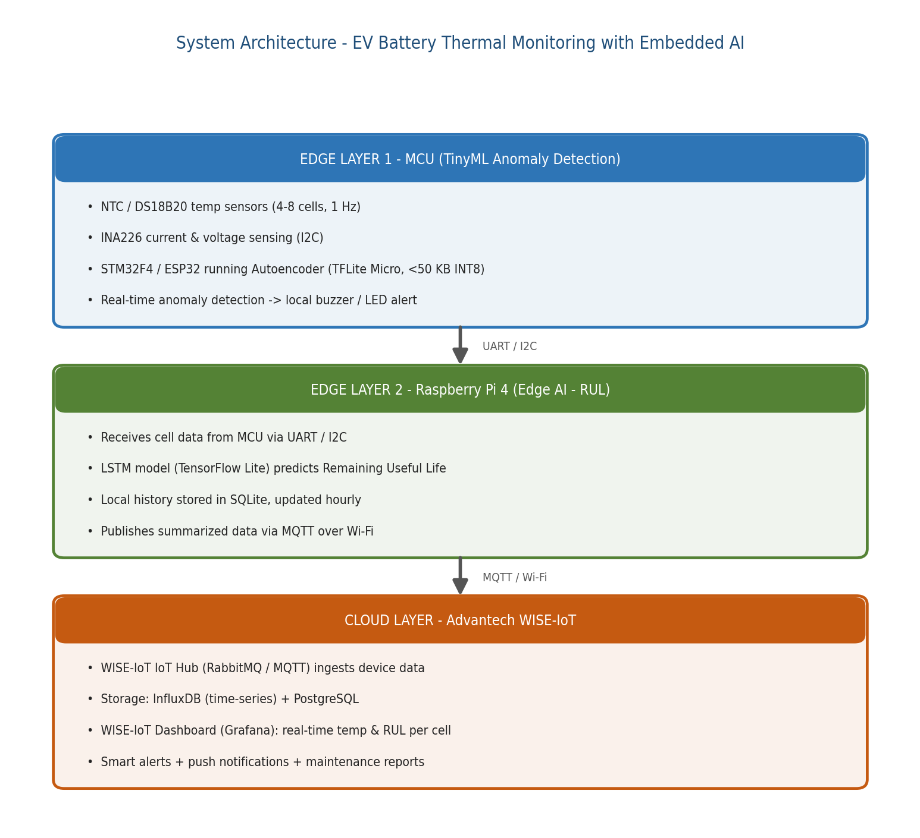
Figure 1. Three-layer Edge AI architecture, with Advantech WISE-IoT as the cloud layer.
How Edge AI / Edge Computing Is Utilized
Edge Layer 1 (TinyML on MCU): An INT8-quantized Autoencoder (<50 KB) runs directly on an STM32F4 / ESP32 using TensorFlow Lite Micro. It learns the normal operating signature of each battery cell and flags deviations in real time, giving an early warning 10-30 minutes before an overheating risk. Because inference is on-device, it keeps working even with no Internet connection.
Edge Layer 2 (Edge AI on Raspberry Pi 4): An LSTM model runs on the Pi 4's ARM Cortex-A72 CPU to predict the battery's Remaining Useful Life (RUL). The task is latency-tolerant (hourly inference), so no GPU is required - reducing cost and power versus edge-GPU boards such as Jetson Nano. Only summarized results are forwarded upstream, which lowers bandwidth and protects against connectivity loss.
Cloud Layer (Advantech WISE-IoT): Summarized data is published via MQTT to the WISE-IoT IoT Hub (RabbitMQ), stored in InfluxDB (time-series) and PostgreSQL, and visualized on the WISE-IoT Dashboard (Grafana) showing real-time per-cell temperature and RUL trends, with smart alerts, push notifications and periodic maintenance reports.
Models are trained offline on the public NASA / CALCE battery dataset (>1,000 labeled charge cycles) and converted to TensorFlow Lite / ONNX for embedded deployment.
Expected Benefits & Practical Impact
- Improved safety: proactive (predictive) detection that prevents fires before they happen, instead of reactive threshold alarms.
- Quantified battery health via the RUL index, enabling planned maintenance and battery replacement.
- Lower cost & longer battery life: prototype hardware under 3.5M VND; target unit ~300,000-500,000 VND plus ~50,000 VND/month SaaS - far below the cost of replacing a battery pack (3-10M VND).
- Scalable business model: hardware module + cloud subscription, expandable from personal EVs to shared fleets, e-buses and battery-storage warehouses.
- Strong alignment with InnoWorks: the WISE-IoT cloud layer is central to the design, satisfying the competition's emphasis on WISE-IoT usage.

